

DEDAN KIMATHI UNIVERSITY OF TECHNOLOGY

University Examinations 2015/2016

FIRST YEAR FIRST SEMESTER EXAMINATION FOR THE DEGREES OF BACHELOR OF SCIENCE IN INFORMATION TECHNOLOGY AND BACHELOR OF SCIENCE IN BUSINESS AND INFORMATION TECHNOLOGY

SMA 2104: MATHEMATICS FOR SCIENCES

DATE: 10th September 2015 TIME: 11.00am – 1.00pm

Instructions: Answer Question ONE And any other TWO Questions.

QUESTION ONE (30 Marks)
- Twelve students in a chemistry practical obtained readings from a practical as shown below:
504, 479, 530, 500, 499, 520, 489, 520, 550, 501, 500, 500.
Determine the mean, median and the semi – inter quartile range all correct to 1 decimal place. [5 Marks]
- A bag holds 7 green beads and 5 yellow beads. Two beads are drawn out of the box without replacement. The events A and B are defined as follows.
A: The 1st bead drawn is green.
B: The two beads picked are of different colours.
Determine P (A), P (B), and P (A/B). [5Marks]
- Mr. Kibaki dines in the same restaurant for three consecutive days and the menu in each day is one of the four types of goat dish, two chicken or one vegetarian dishes. In how many ways can he arrange her lunches over the 3 days if she does not have a goat dish for two running days nor repeat any dish? [5 Marks]

- If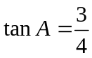 and 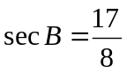 where A and B are acute angles.
Without tables or calculator evaluate 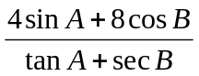 [5 Marks]
- Solve the equation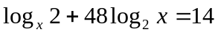. [5 Marks]
- If 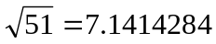 and 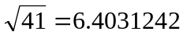 both translated to 7dp .Without using a calculator or mathematical tables , evaluate 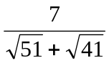 [5 Marks]

QUESTION TWO (20 MARKS)
- State and prove the cosine rule for acute angles. [7 Marks]
- A polynomial 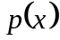 leaves a remainder of 9 when divided by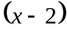 and leaves a remainder of 4 when divided by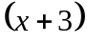. Find the remainder when is divided by 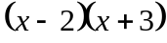. [7 Marks]
- A business woman deposited sh.4, 000 in the beginning of year one and in each subsequent year she increases her savings by 10% of the amount saved in the previous year. How much does she have in her savings after 15 years? What amount is saved during this year? [6 Marks]

QUESTION THREE (20 MARKS)
- i. Use binomial theorem to show that if 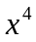 and higher power of x are neglected then:
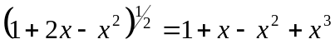 [7 Marks]
ii. By putting 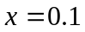 in your expansion estimate 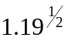 correct to 3 d.p [2 Marks]
- If 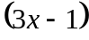 is a factor of 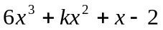, find, the value of k and hence solve the equation 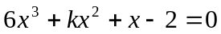. [6 Marks]
- In a Geometric progression, the third term is 81, and the 6th term is 3. Determine the 1st term, the common ratio and the sum to infinity of the series formed. [5 Marks]

QUESTION FOUR (20 MARKS)
The table below gives the distribution of the heights of various plants in a garden.
Height of plant (cm) | Number of plants
40-44 | 2
45-49 | 5
50-54 | 10
55-59 | 16
60-64 | 22
65-69 | 8
70-74 | 4
- State the class width and the modal class. [2 Marks]
- Calculate the mean. [4 Marks]
- Calculate the standard deviation. [4 Marks]
- Calculate the median height. [4 Marks]
- Evaluate the inter quartile range. [6 Marks]

QUESTION FIVE (20 Marks)
- Find the values of between 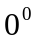and 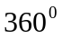 satisfying the equation 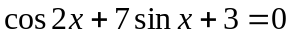 [7 Marks]
- Prove that 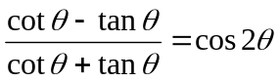. [6 Marks]
- A committee of 7 is to be selected from a group of 10 men and 7 women. How many possible selections are there if there should be a majority of men serving in the committee? [7 Marks]

